|  |  |  |  |
| --- | --- | --- | --- |
| Drug Class | Drugs | Use | Limitations |
|  |  |  |  |
| Non-Specific NSAID Salicylates | Aspirin (ASA)  Trilisate (no antiplatelet activity)  Dolobid  Disalcid | Inflammation  Bone Pain  Osteoarthritis  Dysmenorrhea (PMS) | GI bleeding (PPI)  Renal toxicity  Reduced platelet  Ceiling Effect  Hypertension |
| Specific  NSAID | Celeoxib (Celebrex) | Inflammation  Bone Pain | *CV risk* (0.4%)  No GI bleeding |
|  |  |  |  |
| Acetaminophen (APAP) | APAP 3g/day | Osteoporosis | Liver (alcohol) |
|  |  |  |  |
| Opioid  Strong Agonist | Morphine*** 🡪  Methadone 🡪  Oxycodone (PO only)  Hydromorphone  Fentanyl  Oxymorphone  Meperidine | PCA (patient controlled analgesia)  Cheap uncontrolled pain  Elderly  Epidurals (spine inject) | Renal Impairment  Arrhythmias |
| Opioid  Weak Agonist | Tramadol (Ultram) 🡪  Mu Agonist & NE reuptake inhibitor  Tapentadol (Nucynta) 🡪  Codeine (Tylenol #3)  Hydrocodone | Neuropathic Pain  Acute Pain |  |
| Opioid  Mixed Agonist/anTAG | Butorphanol 🡪  Buprenorphine 🡪  Nalbuphine | Migraines & acute labor  Chronic Pain |  |
| Opioid  Opioid + caffeine + barb | Fiorinal | headaches |  |
|  |  |  |  |
| Nerve Pain  Antidepressants  TCA  Non-TCA  Anticonvulsants  Corticosteroids | Ami**triptyline**, nor**triptyline**  Imi**pramine**, desi**pramine**  Venlafaxine, duloxetine, bupropion  Gabapentin, carbamazepine  dexamethasone | Gaba 🡪 300 mg q8h - titrate |  |

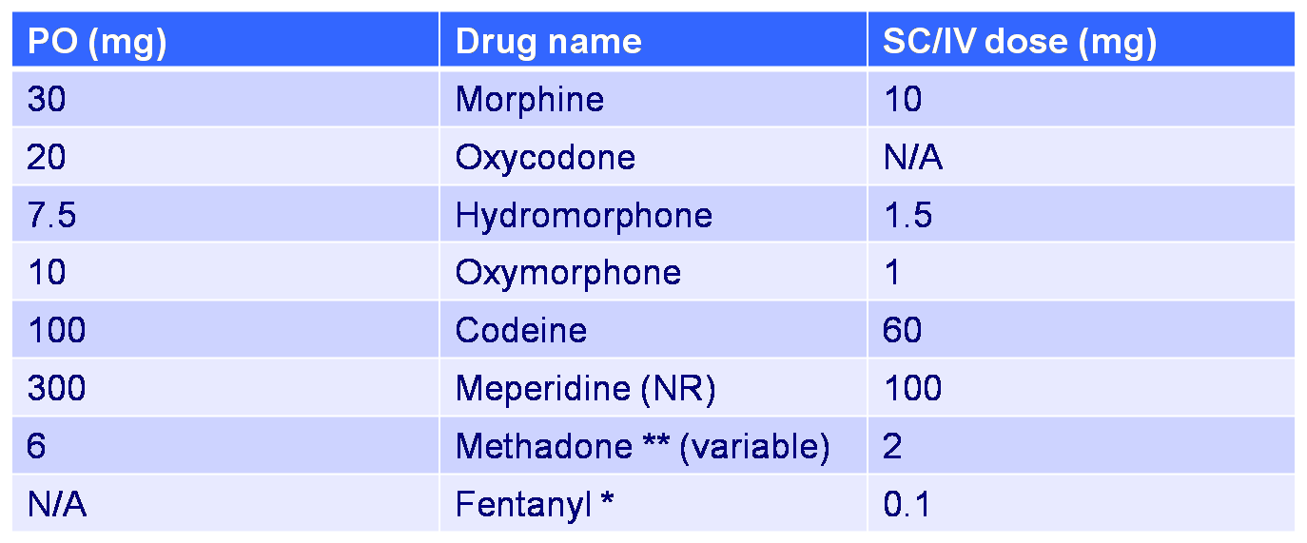

**15 mcg/hr patch**



Nor amicable depressed (tripping) Imp. Desolated

Vendetta fights with a ParaOXatine against a DOXePin

Drug: Morphine (Opioid Strong Agonist)

1. Advantages
   1. No Ceiling Effect
   2. Easy to titrate
2. Disadvantages
   1. M6 metabolite can accumulate in Liver Function
3. Dose
   1. Increase dose, not frequency
4. Dosage Forms
   1. Sustained release
   2. IR tablets
   3. Liquids
   4. Inj

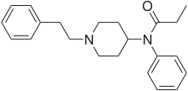Drug: Fentanyl (Opioid Strong Agonist)

1. Advantages
   1. Transdermal 🡪 long lasting
      1. Wear for 72 hours
      2. Onset 12 hours
      3. Therapeutic level 2-3 days
2. Disadvantage
   1. Difficult to titrate
      1. Don’t titrate faster than q 3 days

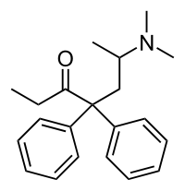Drug: Methadone (Opioid Strong Agonist)

1. Advantage
   1. Long lasting
      1. 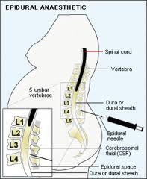Analgesia 4-8 hours
2. Disadvantage:
   1. QT prolongation

Drug: Hydromorphone

1. Advantages
   1. Preferred for epidurals (usually for pregnancy)
   2. Preferred for home infusion

Increase Dose

Breakthrough Pain (initial) 🡪 10 – 20% of daily Use Immediate Release

Moderate Pain 🡪 increase 25 – 50%

Severe Pain 🡪 increase 50 – 100%

Side Effects: Constipation/Obstipation (severe constipation)

Prevention

Bisacodyl (Ducolax) 2 tablets BID-TID

Docusate + Senna 2 tablets BID – TID

Obstipation can use daily

PEG

Milk of Magnesia

Lactulose

Side Effects: Managing Nausea

First line Treatment

NV: prochlorperazine

Second Line

H1 anTAG (allergy): Prometazine

Haloperidol: Antipsychotic (schitzo)

Chlorpromazine antipsychotic (schitzo)

Dronabinol (THC)